Name _________________________________ Number _______
Fill in the blank and answer the questions. Study Guide for Government Test
Constitution George Washington federal Articles of Confederation powers
national Thomas Jefferson senate House of Representatives freedoms
amendments George Mason constitution state Philadelphia

- A ____________________ is a set of rules used to govern people.
- The __________________________________________ was a constitution written during the American Revolution to establish the _____________________ of the new _________________ government.
- What were the five weaknesses of the Articles of Confederation?

- The development of the ____________________ of the United States was significant to the foundation of the American republic.
- The Constitution of the United States of America established a federal system of government based on power being shared between the ___________________ and _________________ governments.
- The delegates to the Constitutional Convention met in ____________________.
- _________________________ was president of the Constitutional Convention.
- What 2 things did the delegates debate over?

- The new government was founded on the separation of powers with three branches. What were the three branches? _________________________________________________________
- The Great Compromise decided how many votes each state would have in the ____________________ and _____________________.
- The Bill of Rights were based on the Virginia Declaration of Rights written by ________________________ and the Virginia Statute for Religious Freedom written by ________________________.
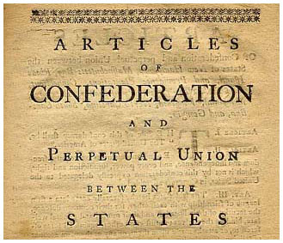
- The Bill of Rights were the first 10 ______________________ to the Constitution and provided a guarantee of individual _____________________.
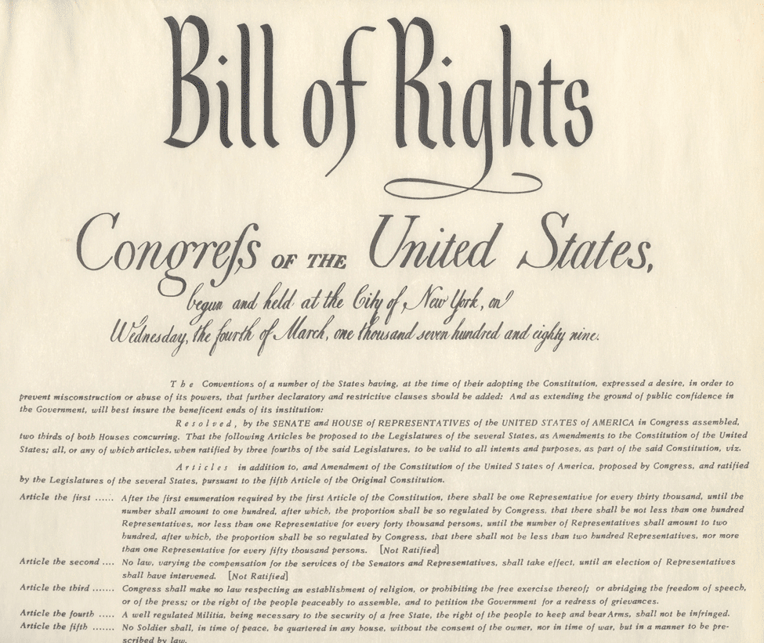
- Put these documents in order.
